Java Assignment -

Thanuja r(192325004)

1.

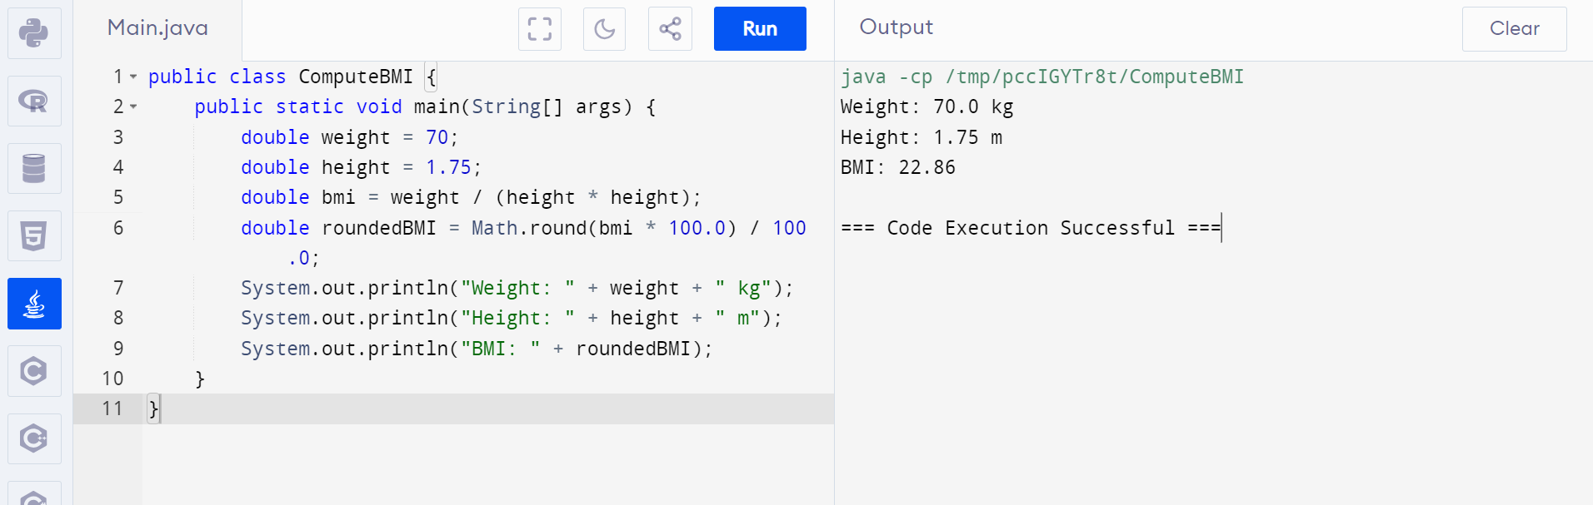

2.

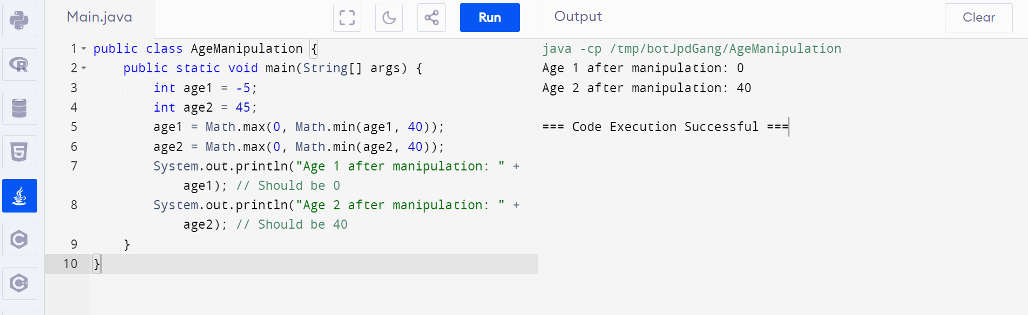

3.

